Evaluation Warning: The document was created with Spire.Doc for Python.

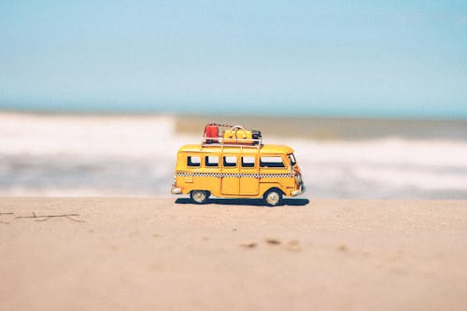



**Adventure Expedition from Punjab to Maharashtra**



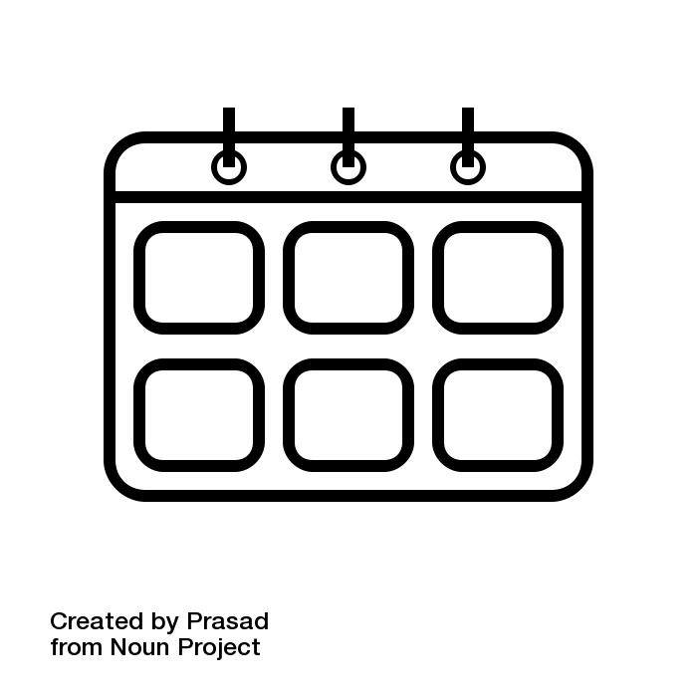Number of Days : 15

Budget Per Person : Rs. 450000.0

Cities : Mumbai, Pune, Nashik, Kolhapur

* Number of Days : 15
* Budget Per Person : Rs. 450000.0
* Cities : Mumbai, Pune, Nashik, Kolhapur
* Number of Days : 15
* Budget Per Person : Rs. 450000.0
* Cities : Mumbai, Pune, Nashik, Kolhapur









- Distance: N/A (arrival)  
- Time: N/A (arrival)  
Today, you will arrive in Mumbai, the vibrant city known for its bustling streets, historic landmarks, and vibrant culture. After checking into your hotel, take some time to relax and unwind from your journey. Enjoy a delicious dinner of local cuisine and get a good night's rest for the adventures ahead.

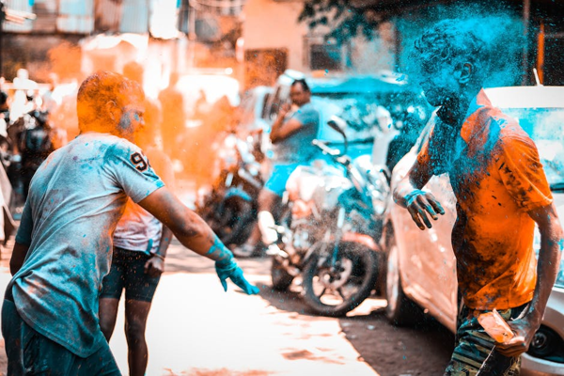

Day 1: Exciting Arrival in Mumbai





- Distance: N/A  
- Time: N/A  
Today, delve into the heart of Mumbai with visits to iconic landmarks such as the Gateway of India, Marine Drive, and the bustling markets of Colaba. Experience the city's fast-paced lifestyle and vibrant energy. Enjoy a leisurely evening by the beach, soaking in the sunset and enjoying some local street food.

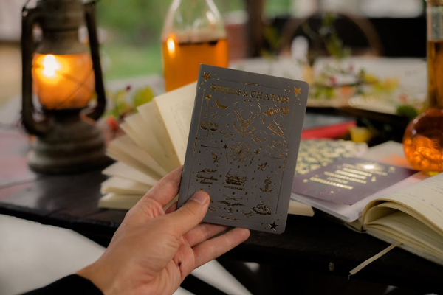

Day 2: Mumbai Magic





- Distance: 150 km (by flight)  
- Time: 1.5 hours (by flight)  
Fly to Pune, known as the cultural capital of Maharashtra. Upon arrival, head to the beautiful countryside for a nature trek in the Western Ghats. Explore the lush greenery and breathtaking views, and later, relax at a tranquil resort amidst nature.

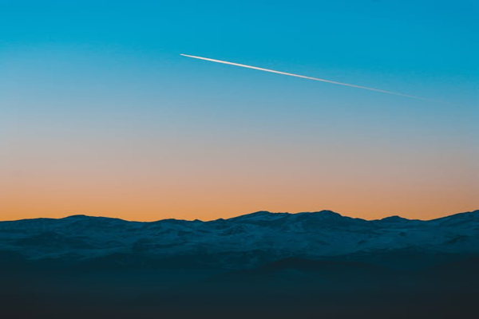

Day 3: Flight to Pune and Nature Trails





- Distance: N/A  
- Time: N/A  
Discover the rich history and architecture of Pune with visits to landmarks like Shaniwar Wada, Aga Khan Palace, and the serene Osho Ashram. Dive into the local culture by exploring vibrant markets and trying traditional Maharashtrian cuisine.

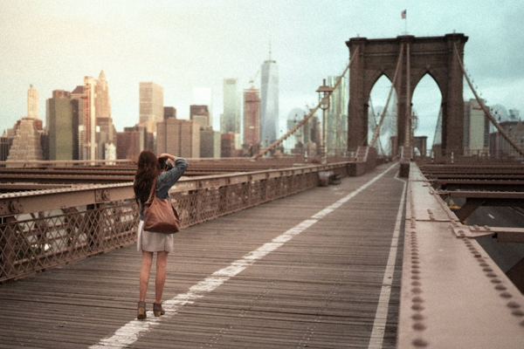

Day 4: Pune City Exploration





- Distance: 210 km  
- Time: 4 hours  
Travel to Nashik, a charming city known for its vineyards and religious importance. Visit a local vineyard for a tour and wine tasting experience. Enjoy the serene countryside and indulge in a peaceful evening amidst the vineyards.

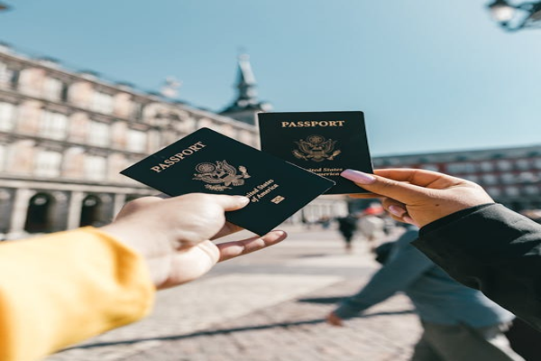

Day 5: Journey to Nashik and Vineyard Excursion





- Distance: N/A  
- Time: N/A  
Explore the spiritual side of Nashik with visits to ancient temples like Trimbakeshwar and Muktidham. Take a dip in the holy waters of the Godavari River and immerse yourself in the peaceful ambiance of the sacred sites.

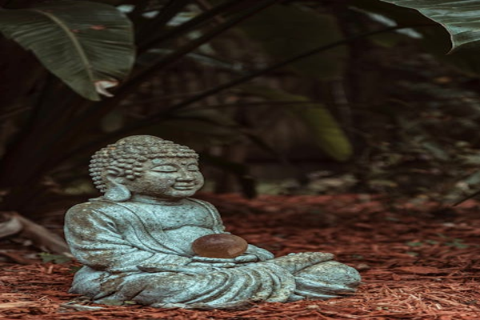

Day 6: Spiritual Retreat in Nashik





- Distance: 330 km  
- Time: 6 hours  
Embark on a scenic drive to Kolhapur, a city famed for its historical significance and culinary delights. Enjoy the picturesque landscapes along the way and check into a cozy hotel upon arrival.

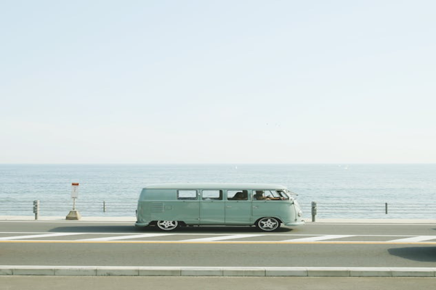

Day 7: Leisurely Drive to Kolhapur





- Distance: N/A  
- Time: N/A  
Immerse yourself in the rich cultural heritage of Kolhapur with visits to the majestic Mahalaxmi Temple, New Palace, and Rankala Lake. Explore the bustling markets for local handicrafts and souvenirs.

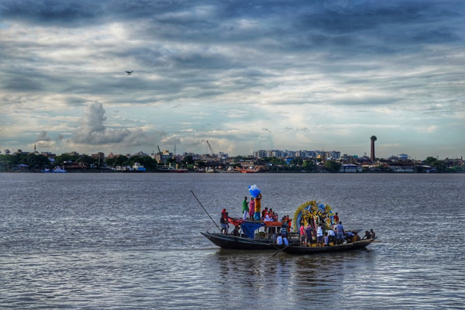

Day 8: Kolhapur Cultural Immersion





- Distance: N/A  
- Time: N/A  
Get your adrenaline pumping with thrilling adventure activities like trekking, zip-lining, or river rafting in the scenic surroundings of Kolhapur. Feel a rush of excitement as you explore the great outdoors and push your limits.



Day 9: Adventure Activities in Kolhapur





- Distance: 375 km  
- Time: 7 hours  
Bid farewell to Kolhapur as you make your way back to Mumbai. Enjoy the scenic drive through the countryside and reminisce about the unforgettable experiences you've had on this adventure-filled journey.

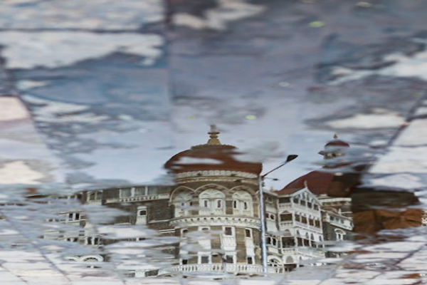

Day 10: Return to Mumbai





- Distance: N/A  
- Time: N/A  
Spend your last day in Mumbai exploring the vibrant markets for souvenirs, handicrafts, and trendy fashion items. Shop till you drop at popular shopping districts like Colaba Causeway, Linking Road, and Crawford Market.

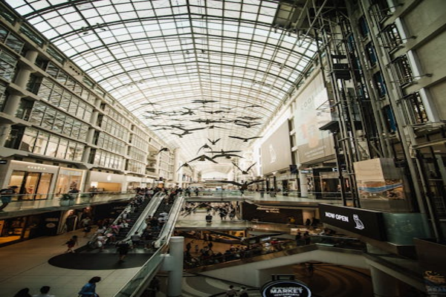

Day 11: Shopping Extravaganza in Mumbai





- Distance: N/A  
- Time: N/A  
Indulge in a culinary journey through Mumbai, sampling local street food, traditional snacks, and gourmet delights. Taste the diverse flavors of Maharashtra with a delicious food tour around the city.



Day 12: Culinary Delights of Mumbai





- Distance: N/A  
- Time: N/A  
Immerse yourself in the cultural heritage of Mumbai with visits to museums, art galleries, and historic sites. Discover the city's rich history and artistic legacy through interactive exhibits and insightful tours.



Day 13: Cultural Experiences in Mumbai





- Distance: N/A  
- Time: N/A  
Enjoy a leisurely day in Mumbai, relaxing at a spa or on the beach, reflecting on the memories you've created during your epic journey from Punjab to Maharashtra. Bid farewell to the city with a final dinner with your friends, savoring the moments shared together.

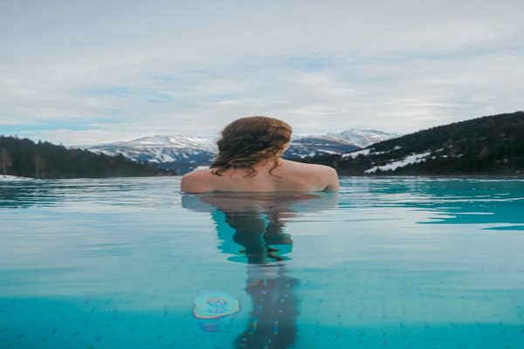

Day 14: Relaxation and Farewell





- Distance: N/A (departure)  
- Time: N/A (departure)  
After an unforgettable adventure across Punjab and Maharashtra, it's time to say goodbye to Mumbai. Depart for your journey back home, carrying with you memories of thrilling experiences, scenic landscapes, and cultural discoveries. Until next time, happy travels!

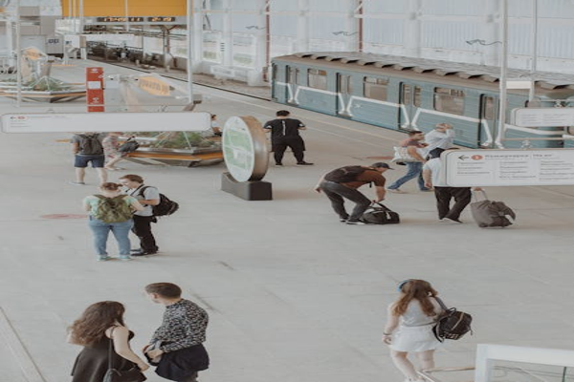

Day 15: Departure from Mumbai